**HEADER OF FRONT PAGE*** Twitter logo Facebook logo



TABS UNDER HEADING  Betting Accessories/ book

*SUB TAB   

***Odds Comparison Tab – All the sports down left hand side – this is just a sample of content

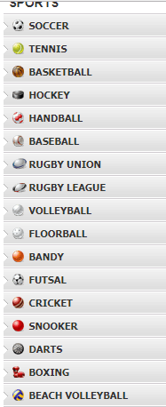
TO THE RIGHT HAND SIDE OF SPORTS ABOVE
**EXAMPLE OF IN PLAY TAB
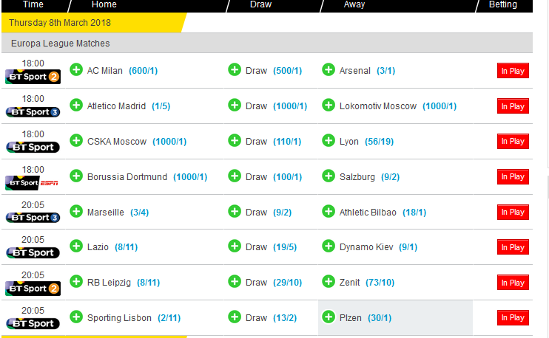

EXAMPLE OF NEXT MATCHES TAB

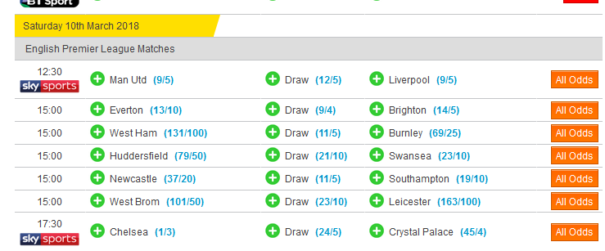

**EXAMPLE OF ALL EVENTS TAB

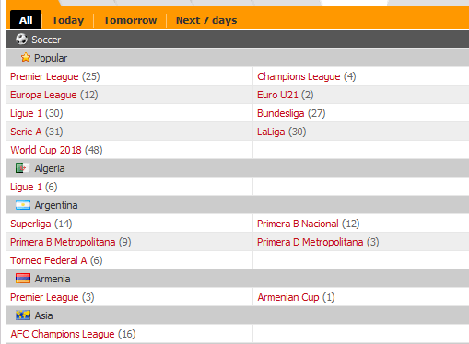

This kind of general style would be good if possible

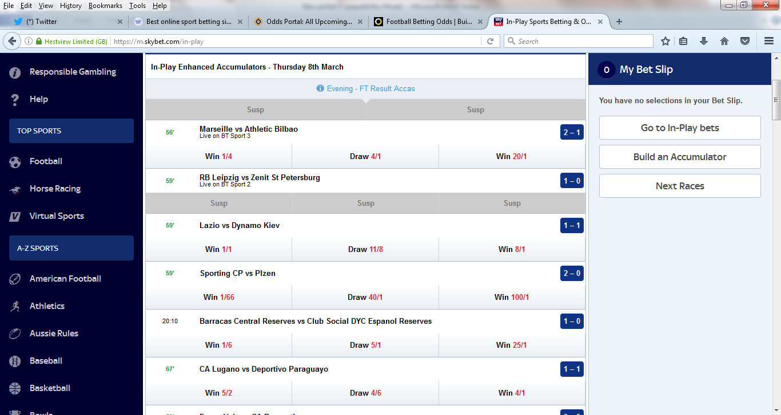

Bookmakers Tab – This will be the tab that is on the website already www.rockstarsportsbook.com
https://top.rockstarsportsbook.com

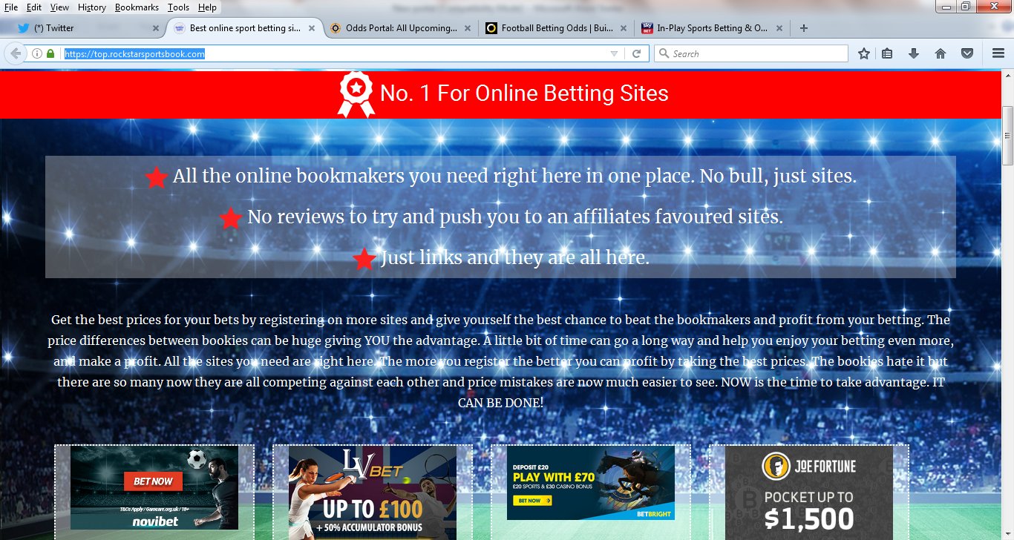

LIVE SCORES TAB

Something along these lines

